**Christian J. Harris**

3905 State St, Suite 7374 - Santa Barbara, CA 93105

email: [christian.harris@live.com](mailto:Christian.harris@live.com) phone: 480.516.7162

April 2nd, 2019

**SONOS, Inc.**

**614 Chapala St.**

**Santa Barbara, CA 93101**

Dear Hiring Manager:

Having been referred by SONOS Web Development Engineer Brandon Scott, I am eager to join your organization as a technical yet creative *Senior Packaging Engineer*. Music is one of the most amazing gifts we have, so I cannot wait contribute towards the SONOS user experience of being immersed in it.

My experience is considerably well-rounded in both the sciences and creative endeavors. My most relevant experiences are my 5 years as a Product Development Engineer, which included Industrial Design and Design of Experiments (DOX) analyses; my 9 years as a Photography Director for various Marketing clients; my 15 years of Tutoring hundreds of students towards conceptualizing advanced topics, including Physics; and the past year in which I have been Manufacturing Tech Coordinator for Agilent Technologies.

In this current position, I have had the hands-on opportunity to assess the Assembly pros and cons of using both rigid and flexible packaging materials of varying complexity. I am aware first-hand of the man-hour effects that certain packaging types can have on a production line, yet also understand how efficient packaging yields a more intuitive unboxing experience for the end-user. As a 5-year Engineer, I designed products in which both their aesthetic and their ease-of-use were nearly as important in protecting individual soldiers as their operational specifications. I can apply this same Usability-Functionality dichotomy towards the music streaming user experience.

Note that my experience diversity showcases how effective I am at self-learning what is necessary to get the job done. Having also developed Marketing material for over 160 compilations across nearly every genre of music, my love for all types of music will certainly be a driving force in ensuring that every customer has the most immersive experience. My appreciation for all things creative and my technical versatility make me flexible towards engineering designs that fuel art. Feel free to reach me at (480) 516-7162. Thank you for this amazing opportunity!

Sincerely,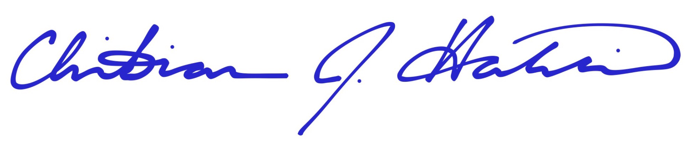

Christian J. Harris

**Christian J. Harris**

3905 State St, Suite 7374 - Santa Barbara, CA 93105

email: [christian.harris@live.com](mailto:Christian.harris@live.com) phone: 480.516.7162

**Summary:** Master’s degree professional with over a decade of experience including Hardware Engineering, Test Design, multivariate data analysis, Technical Drafting via SolidWorks, and Manufacturing Process Selection

**EMPLOYMENT HISTORY**

Agilent Technologies | Carpinteria, CA

**Manufacturing Tech Coordinator,** March 2018-present

* Develop optimization for the quality, flow, and efficiency of assembling kits of varied complexity

University of California at Santa Barbara | Santa Barbara, CA

**Calculus/Physics Instructor,** September 2013-May 2017

* Taught in front of classrooms of up to 100 students how to learn and organize advanced concepts

Self-Employed | Santa Barbara, CA

**Private Mathematics & Science Tutor,** September2011-present

* Steadily self-learn new material and real world problems to apply new insight towards instruction
* Provide nimble solution building for advanced topics, including Calculus, Physics, Statistics, and more
* Create custom-built curriculums for non-student, working Professionals and homeschoolers

Crimson Fox Photography LLC | Phoenix, AZ / Santa Barbara, CA

**Photography Director / Owner,** January 2008-October 2017

* Created Marketing images for restaurants, entertainment venues, musicians, movies, etc.
* Wrote, negotiated, and developed contracts and pricing structures for Corporate events and Film

BAE Systems / Armor Holdings Aerospace & Defense Group | Phoenix, AZ

**Product Development Engineer / Project Engineer,** October 2006-April 2011

* Developed products from their Industrial Design to Material Selection to Test Design to Manufacturing
* Drafted technical drawings via SolidWorks for prototypes created by various methods
* Presented beta prototypes to end-users and Military officials for hands-on, Usability feedback
* Kept projects within budget, designing minimal part numbers/sizes while optimizing functionality
* Designed and performed test protocols/data analysis for products in mixed stages of development
* Wrote patents, manuals, and technical Military documents for official use

**EDUCATIONAL DEVELOPMENT**

Duke University | Durham, NC

**Master of Science in Mechanical Engineering & Materials Science,** December 2005

Certificate: *Biologically Inspired Materials and Material Systems (CBIMMS Program)*

Thesis: *Parameter Design & Characterization of Threshold Biosensing Electromechanical Microcantilevers*

* Fostered relationships with local tech companies to develop MEMS materials needed for research

North Carolina Central University | Durham, NC

**Bachelor of Science in Physics,** May 2002 – Magna Cum Laude

University of North Carolina at Chapel Hill | Chapel Hill, NC

**Physics Intern,** June 2001-July 2001

**Training:** Design of Experiments, SolidWorks, AutoCAD, Adobe Photoshop CS5

**Other:** performed concept development of over 160 album covers for artists in nearly every genre of music